|  |
| --- |
|  |
| Projekthandbuch |
| Incidence Response Model For Covid-19 |
| Version 01 vom 10.05.2  **Betreuerin und Betreuer:**  **Prof. Dr. Maria Wimmer, Dr. Ulf Lotzmann** |
| **Teilnehmende im Projektteam:**  Irshad Hussain Mohammed, Manpreeth Vankadara, Nirav Satani,  Pavan Kumar Tokachichu, Pavan Kumar Reddy Kancharla,  Peram Navachandu Reddy, Ramesh Reddy Modulla, Rehan Ali Syed  Sudheer Kumar Gandham, Venkata Satya Aditya Jagarlapudi |
| **Abgeschlossen am: 11.07.2022** |

|  |
| --- |
|  |

Inhaltsverzeichnis

1. Einleitung .............................................................................................................................2

2. Projektmanagement.............................................................................................................3

2.1 Übersicht der Beteiligten...................................................................................3

2.2 Aufgabenverteilung............................................................................................3

2.3 Gantt Chart........................................................................................................3

2.4 Meetings............................................................................................................6

2.5 Communication Medium....................................................................................7

2.6 Plan of Action.....................................................................................................7

3. Methods and Tools........................................................................................................9

3.1 Methods.............................................................................................................9

3.2 Tools................................................................................................................10

4. Individual Contribution.................................................................................................11

# Einleitung

The rise of Covid-19 has not only taken many lives but also made us aware that no matter how much we ascend in terms of medicine, technology we are still not prepared to handle Pandemics. In this Research Lab, we look forward to build an Incidence Response Model which could help Governments in taking decisions with the data they have in their hands.

Our Model aims at acquiring the data of flights, population density of countries and analysing it to classify the regions into High, Medium and Low risk areas.

What Required Objectives Does the Model Meet?

* Helps in Better Understanding of the pandemic situation.
* Reduces complexity for categorization of regions.
* Able to Analyse and Interpret data reliably, and quickly.
* Helps decision makers with decision recommendations.

What data can be explored from existing data sources?

The data on modes of international transportation should be obtained from the vast data lakes and transformed and added transitive properties to the data as required.What methods for data analysis from the areas of AI, big data/big data analytics, data science, and statistical methods can be applied to the available data?

The data analysis methods are going to be obtained-data dependent, mostly fromAnalysis methods such as Data Mining, Time Series Analysis

# Projektmanagement

## Übersicht der Beteiligten

Term 01

|  |  |  |
| --- | --- | --- |
| **Projektorganisation** | | |
| **Projektrolle** | **Name** | **E-Mail** |
| Projektauftraggeber | * Forschungsgruppe E-Government | egov@uni-koblenz.de |
| Projektleiter | * Sudheer Kumar Gandham * Nirav Satani | * [sudheerkumargandham@uni-koblenz.de](mailto:sudheerkumargandham@uni-koblenz.de) * [Niravsatani24@uni-koblenz.de](Consider%20it.pptx) |
| Projektteammitglieder | * Irshad Hussain Mohammed * Manpreeth Vankadara * Pavan Kumar Tokachichu * Pavan Kumar Reddy Kancharla * Peram Navachandu Reddy * Ramesh Reddy Modulla * Rehan Ali Syed * Venkata Satya Aditya Jagarlapudi | * [imohammed@uni-koblenz.de](mailto:imohammed@uni-koblenz.de) * [manu@uni-koblenz.de](mailto:manu@uni-koblenz.de) * [pavankumar@uni-koblenz.de](mailto:pavankumar@uni-koblenz.de) * [pavan.kancharla@uni-koblenz.de](mailto:pavan.kancharla@uni-koblenz.de) * [navachandu@uni-koblenz.de](mailto:navachandu@uni-koblenz.de) * [modullarameshreddy@uni-koblenz.de](mailto:modullarameshreddy@uni-koblenz.de) * [syedali@uni-koblenz.de](mailto:syedali@uni-koblenz.de) * [adityajvs@uni-koblenz.de](mailto:adityajvs@uni-koblenz.de) |
| Projektbetreuer | Prof. Dr. Maria A. Wimmer  Dr. Ulf Lotzmann | [wimmer@uni-koblenz.de](mailto:wimmer@uni-koblenz.de" \o "mailto:wimmer@uni-koblenz.de)  [ulf@uni-koblenz.de](mailto:ulf@uni-koblenz.de" \o "mailto:ulf@uni-koblenz.de) |

## Aufgabenverteilung

* Irshad Hussain Mohammed - Documentation, Minutes of Meeting, Data Analysis Team, Architecture.
* Manpreeth Vankadara - Algorithms and Artifacts Research
* Nirav Satani - Management, Algorithms, Artifacts
* Pavan Kumar Tokachichu - Documentation, Minutes of Meeting, Data Analysis Team, Architecture
* Pavan Kumar Reddy Kancharla - Algorithms and Artifacts Research
* Peram Navachandu Reddy - Algorithms and Artifacts Research
* Ramesh Reddy Modulla - Data Acquisition and Preparation
* Rehan Ali Syed - Data Acquisition and Preparation
* Sudheer Kumar Gandham - Management, Data Acquistion, Preparation.
* Venkata Satya Aditya Jagarlapudi - Data Acquisition and Preparation

Term 02

|  |  |  |
| --- | --- | --- |
| **Projektorganisation** | | |
| **Projektrolle** | **Name** | **E-Mail** |
| Projektauftraggeber | * Forschungsgruppe E-Government | egov@uni-koblenz.de |
| Projektleiter | * Ramesh Reddy Modulla * Rehan Ali Syed | * [modullarameshreddy@uni-koblenz.de](mailto:modullarameshreddy@uni-koblenz.de) * [syedali@uni-koblenz.de](mailto:syedali@uni-koblenz.de) |
| Projektteammitglieder | * Irshad Hussain Mohammed * Manpreeth Vankadara * Pavan Kumar Tokachichu * Pavan Kumar Reddy Kancharla * Peram Navachandu Reddy * Sudheer Kumar Gandham * Nirav Satani * Venkata Satya Aditya Jagarlapudi | * [imohammed@uni-koblenz.de](mailto:imohammed@uni-koblenz.de) * [manu@uni-koblenz.de](mailto:manu@uni-koblenz.de) * [pavankumar@uni-koblenz.de](mailto:pavankumar@uni-koblenz.de) * [pavan.kancharla@uni-koblenz.de](mailto:pavan.kancharla@uni-koblenz.de) * [navachandu@uni-koblenz.de](mailto:navachandu@uni-koblenz.de) * [sudheerkumargandham@uni-koblenz.de](mailto:sudheerkumargandham@uni-koblenz.de) * [Niravsatani24@uni-koblenz.de](Consider%20it.pptx)   [adityajvs@uni-koblenz.de](mailto:adityajvs@uni-koblenz.de) |
| Projektbetreuer | Prof. Dr. Maria A. Wimmer  Dr. Ulf Lotzmann | [wimmer@uni-koblenz.de](mailto:wimmer@uni-koblenz.de" \o "mailto:wimmer@uni-koblenz.de)  [ulf@uni-koblenz.de](mailto:ulf@uni-koblenz.de" \o "mailto:ulf@uni-koblenz.de) |

## Aufgabenverteilung

* Irshad Hussain Mohammed - Documentation, Minutes of Meeting, Data Analysis Team, Architecture.
* Manpreeth Vankadara - Algorithms and Artifacts Research
* Nirav Satani - Management, Algorithms, Artifacts
* Pavan Kumar Tokachichu - Documentation, Minutes of Meeting, Data Analysis Team, Architecture
* Pavan Kumar Reddy Kancharla - Algorithms and Artifacts Research
* Peram Navachandu Reddy - Algorithms and Artifacts Research
* Ramesh Reddy Modulla - Management, Data Acquisition and Preparation
* Rehan Ali Syed - Management, Data Acquisition and Preparation
* Sudheer Kumar Gandham - Correlation
* Venkata Satya Aditya Jagarlapudi - Data Acquisition and Preparation

Term 03

|  |  |  |
| --- | --- | --- |
| **Projektorganisation** | | |
| **Projektrolle** | **Name** | **E-Mail** |
| Projektauftraggeber | * Forschungsgruppe E-Government | egov@uni-koblenz.de |
| Projektleiter | * Irshad Hussain Mohammed * Peram Navachandu Reddy | * [imohammed@uni-koblenz.de](mailto:imohammed@uni-koblenz.de) * [navachandu@uni-koblenz.de](mailto:navachandu@uni-koblenz.de) |
| Projektteammitglieder | * Irshad Hussain Mohammed * Manpreeth Vankadara * Pavan Kumar Tokachichu * Pavan Kumar Reddy Kancharla * Peram Navachandu Reddy * Ramesh Reddy Modulla * Rehan Ali Syed * Venkata Satya Aditya Jagarlapudi * Sudheer Kumar Gandham * Nirav Satani | * [manu@uni-koblenz.de](mailto:manu@uni-koblenz.de) * [pavankumar@uni-koblenz.de](mailto:pavankumar@uni-koblenz.de) * [pavan.kancharla@uni-koblenz.de](mailto:pavan.kancharla@uni-koblenz.de) * [modullarameshreddy@uni-koblenz.de](mailto:modullarameshreddy@uni-koblenz.de) * [syedali@uni-koblenz.de](mailto:syedali@uni-koblenz.de) * [adityajvs@uni-koblenz.de](mailto:adityajvs@uni-koblenz.de) * [sudheerkumargandham@uni-koblenz.de](mailto:sudheerkumargandham@uni-koblenz.de) * [Niravsatani24@uni-koblenz.de](Consider%20it.pptx) |
| Projektbetreuer | Prof. Dr. Maria A. Wimmer  Dr. Ulf Lotzmann | [wimmer@uni-koblenz.de](mailto:wimmer@uni-koblenz.de" \o "mailto:wimmer@uni-koblenz.de)  [ulf@uni-koblenz.de](mailto:ulf@uni-koblenz.de" \o "mailto:ulf@uni-koblenz.de) |

## Zeitplan – Gantt Chart

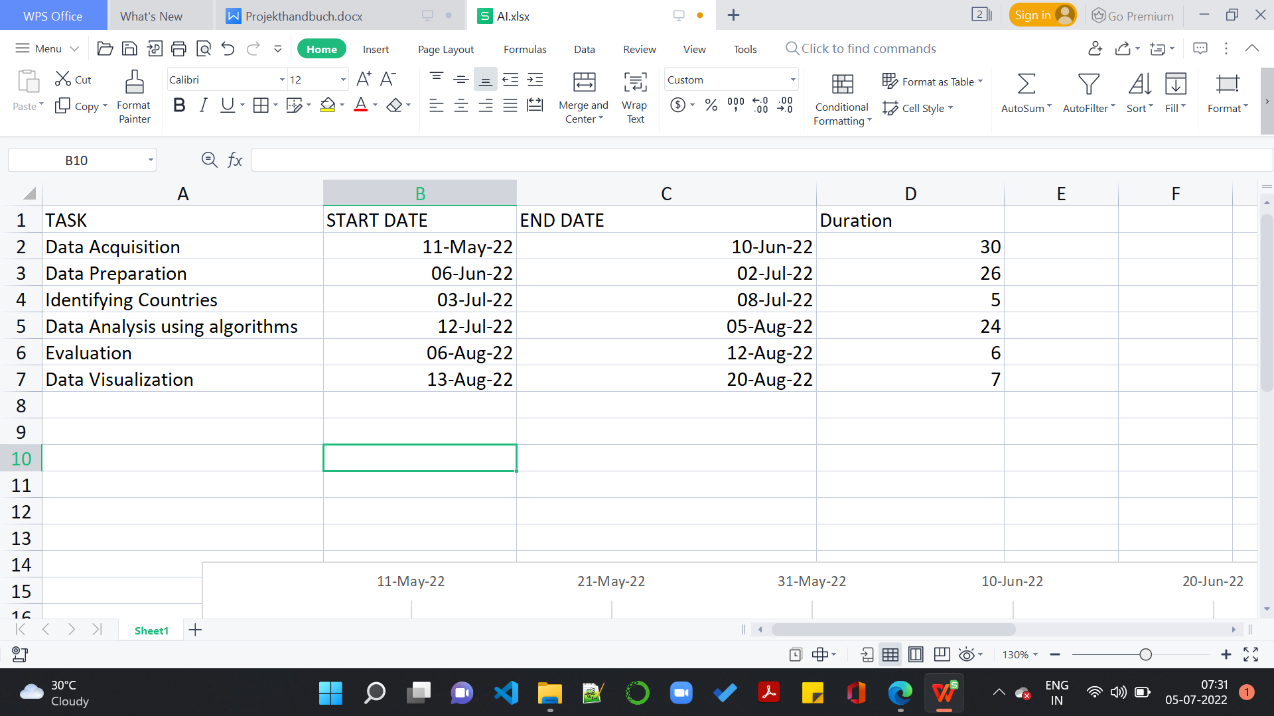

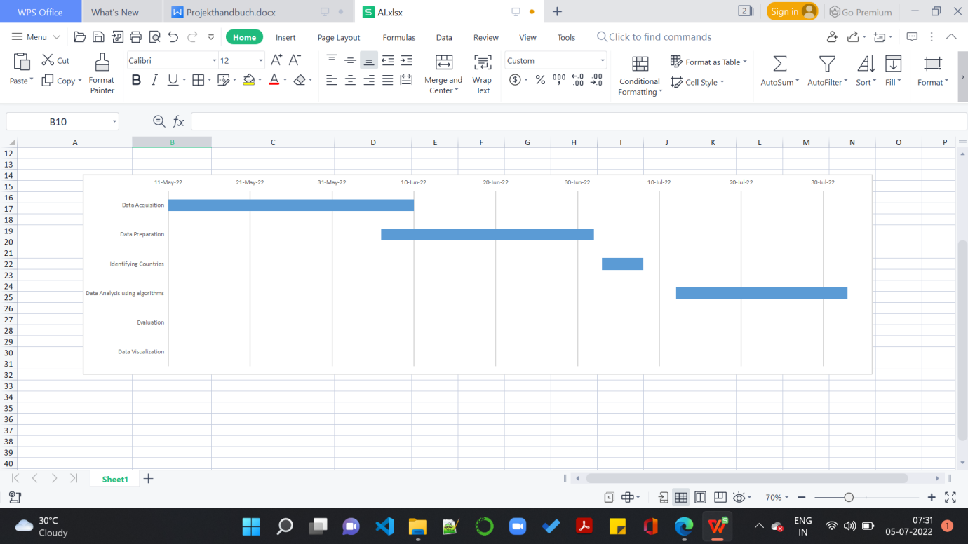

## Meetings

From the start of the Research Lab. Our Team has been holding meeting regularly

The Meeting schedules were on:

11.05.2022 -18:00 Meeting for Separation of Tasks

18.05.2022 -18:00 Meeting to discuss hurdles in Data Acquisition

25.05.2022 -18:00 Meeting to discuss Algorithms and Data Acquisition

06.06.2022 - 10:00 Getting Ready with Updated Status

14.06.2022 - 10:30 Meeting to get Status

18.06.2022 - 10:30 Preparing Deliverable for Presentation 2

24.06.2022 -18:30 Separation of Tasks

01.07.2022 - 18:30 Update on Deliverable

08.07.2022-18:30 Meeting in General

## Kommunikationsmedien

The medium of Communication was online via Microsoft Teams

## Plan of Action

**Version -1**

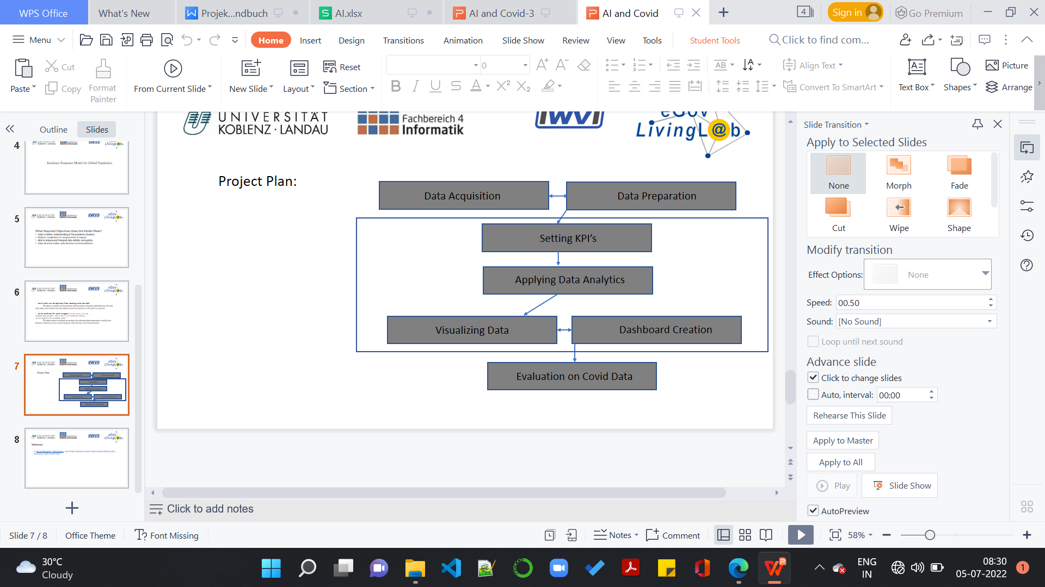

**Version -2**

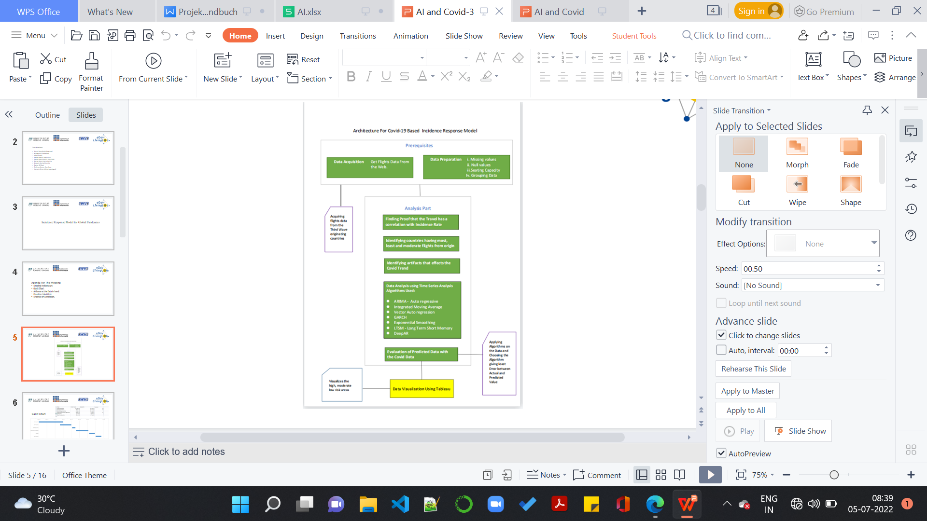

# Methodisches Vorgehen und Werkzeuge

## Methoden

**Data Acquisition:**

Acquiring Chinese Data:

The idea of the project is to acquire the Chinese travel data and analyse the destination countries for covid cases. We used Web Crawling techniques and we crawled websites but it turned out that Chinese flight data is not available in the Internet. The Chinese Government doesn’t allow ADS-B method which is asked to track flights.

We tried paid websites for data but it took long time. So we decided to move forward with data available in Internet

Acquiring Data of Omicron Variant:

According to WHO, the[SARS-CoV-2 Omicron variant](https://en.wikipedia.org/wiki/SARS-CoV-2_Omicron_variant" \o "SARS-CoV-2 Omicron variant) (B.1.1.529), first reported from South Africa in November 2021.

So, we decided to acquire data from South Africa and UK (first case on 27 November , but cases skyrocketed)

The problem with Omicron Variant is that it is different from the variant recorded and Community transmission was a big hurdle in front of us. So we decided to pull the population density of the destination Countries and find correlation between Population and Covid

**Data Preparation**

After The Data has been acquired from the [https://zenodo.org/record/6411336](https://zenodo.org/record/6411336" \o "https://zenodo.org/record/6411336) We have filtered the South African and UK origin Flights. We have removed the unnecessary fields and Identified unique destinations. From those Unique Destinations we have provided the file to Data Analysis Team to Identify countries for Analysis

**Identifying Countries:**

We have taken out the prepared data and chosen 5 countries having high, moderate and low incoming traffic from South Africa and Great Britain each

**Finding the Seating Capacity:**

There were no Passenger Count available in the data. So we also pulled the Aircraft Model and its seating capacity. According to travel restrictions at Omicron period we mapped the seating capacity with the flight.

**Data Analysis:**

For Data Analysis we have a dedicated team , who are working on finding the artifacts for analysis and finding out the algorithms could be used for analysis of our Data

After Research we have decided to Use Time Series Analysis and we will be Using the following Algorithms for our Analysis:

1. ARIMA
2. Vector Auto Regresssion
3. Prophet
4. Exponential Smoothing
5. LSTM
6. Deep AR

## Werkzeuge :

* Project Management – Open Project
* Cloud - Github
* Programming Language - Python
* Libraries - Pandas,Numpy, Matplotlib, TensorFlow, keras
* Documentation - Microsoft Word

# 4. Individual Contribution:

In this section, we have documented the individual work we have been doing

1. **Irshad Hussain Mohammed** :

Being a part of the team, I worked on the Research Idea and proposed it to the team members. Once it got approved, I got in contact of team managers and contacted them for working on Project plan, Timelines, working on the Documentation Parts, Architectures. I was always with the project managers and had been a crucial part in holding meetings, planning deadlines.

In addition to that, technically I have been a part of Data Analysis Team where I worked with the Data Analysis Team in finding the artifacts for Data Analysis and communicated with the Data Acquisition Team to pull the data from sources.

I was a part of Data Preparation Team where I was conceptualizing the Data to be prepared.

I contributed to this Research project by identifying a finite number of countries for analysis

I am the in charge of Gantt Charts, Documentations, Minutes of Meeting and Powerpoint Presentations.

As a part of Data Analysis Team , I am training the data on LSTM algorithm.

1. **Ramesh Reddy Modulla:**

I am part of the Data Acquisition Team, Supporting the team by providing the required data like Countries, Flight information, Covid cases. All the data is shared with Data Analysis Team for analysing the co-relation. Apart from this, I am also responsible for GitHub. All the codes and documents are uploading time to time.

3. **Pavan Kancharla**

I am a part of both Data Acquisition and Data Analysis where I worked on finding the correlation between the Active cases in 25 countries (which are classified as high, medium, and low severity based on their exposure to COVID 19 during November, December, and January 2021) and its population per meter square and as a part of which I have collected and then cleaned the data and used it further to analyse it. I have represented them over a graph which turned out to be linear and finally, I observed the correlation between them to be around 53% which turned out to be moderate analyze.

4. **Peram Navachandu Reddy**

I am Part of Data Analysis team. I did research on finding the different artifacts and proposed to the team. I also worked on different algorithms and proposed to the team members and once we finalized the algorithms.

I am training the data on ARIMA, Exponential Smoothing and Vector Auto Regression algorithms.

5. **Nirav Satani**

I was the project manager of the team for two weeks. In the meantime, I was responsible to coordinate with professors and team members, gathering documentation and uploading it to the cloud, and arranging meetings.

Moreover, I am part of the Data Analysis team, supporting the team by doing data pre-processing, data cleaning, and finding artifacts. In addition to this, I gave support by doing research on the correlation between features.

Currently, I am responsible for how to use the Deep AR algorithm for forecasting. I made a documentation of this algorithm with a flow chart for future purposes.

6. **Sudheer Kumar Gandham**

I was initially a part of the data acquisition team wherein I supported the team in getting various data sets that are needed for the analysis team. I also played the role of project manager for an ample amount of time wherein I arranged the weekly/monthly meetings, coordinated with the team members, updating presentations/minutes of meeting in the next cloud. thereafter I've worked with the Data Analysis team on finding correlations between different countries' populations and active cases reported in a specified period.

7. **Vankadara Manpreeth**

I am a team member in Data acquisition and also in Data Analysis. I created Gannt chart that helps in project and production timeline and resource management. I worked with analysis team in finding different artifacts. I researched on timeseries forecasting algorithms, GARCH and PROPHET. I will implement our data on PROPHET.

8. **Pavankumar Tokachichu**

Being a part of the team, I was in contact with team managers and contacted them for working on Project plan, Timelines, working on the Documentation Parts, Architectures. I was always with the project managers and had been a crucial part in holding meetings, planning deadlines.

In addition to that, technically I have been a part of Data Analysis Team where I worked with the Data Analysis Team in finding the artifacts for Data Analysis.

I contributed to this Research project by identifying a finite number of countries for analysis

I am the in charge of Gantt Charts, Documentations, Minutes of Meeting and Powerpoint Presentations.

As a part of Data Analysis Team , I am training the data using LSTM algorithm and I am also the member of team for data visualization.

9**.Venkata Satya Aditya Jagarlapudi**

I am a team member in Data acquisition. I worked on fetching the data. Cleaning the data. Using the mapped data of population density to flights and then mapping it to seat capacity. Using Covid API to fetch cases data and then combine everything into a dataset for South Africa and UK. Then basic Plots to visualize the data. Applied basic clustering on dataset.